Department of Computer Science and Engineering (Data Science)
CSDS-A | Batch A7 (CSE - Data Science, Section A)
SHEGUARD: AI Powered Women's Safety Platform
S.No. | Student name | Roll / hall ticket no.
1 | CH.AARTHI | 23K91A6741
2 | D.PRANATHI | 23K91A6748
3 | BALA VIGNESH | 23K91A6717
4 | A.VISHAL | 23K91A6704
Under the guidance of: [GUIDE NAME], [DESIGNATION]
BLOCK DIAGRAMS
This document collects every design diagram of SHEGUARD. Each diagram was drawn from the real code, database models and routes and is followed by a paragraph that explains it. The diagrams were generated by scripts/make_diagrams.py with matplotlib.
Table 1: Diagrams in this document
No. | Diagram | Shows
1 | System architecture | Browser, React web app, FastAPI routers and services, risk model and district table, SQLite, evidence files, external services
2 | High-level workflow | From registration and route planning to SOS, live tracking, evidence and cancellation
3 | DFD level 0 | Context: SHEGUARD and its external entities
4 | DFD level 1 | Main processes and data stores
5 | DFD level 2 | Expansion of the safe-route planning process
6 | Use-case diagram | Actors and their use cases
7 | Sequence diagram | Starting an SOS, streaming location, uploading evidence and cancelling
8 | ER diagram | Six database tables
9 | UML class diagram | Domain entities, services and routers
10 | Algorithm flowchart | Control flow of route scoring and of the SafePhrase match

1 System Architecture
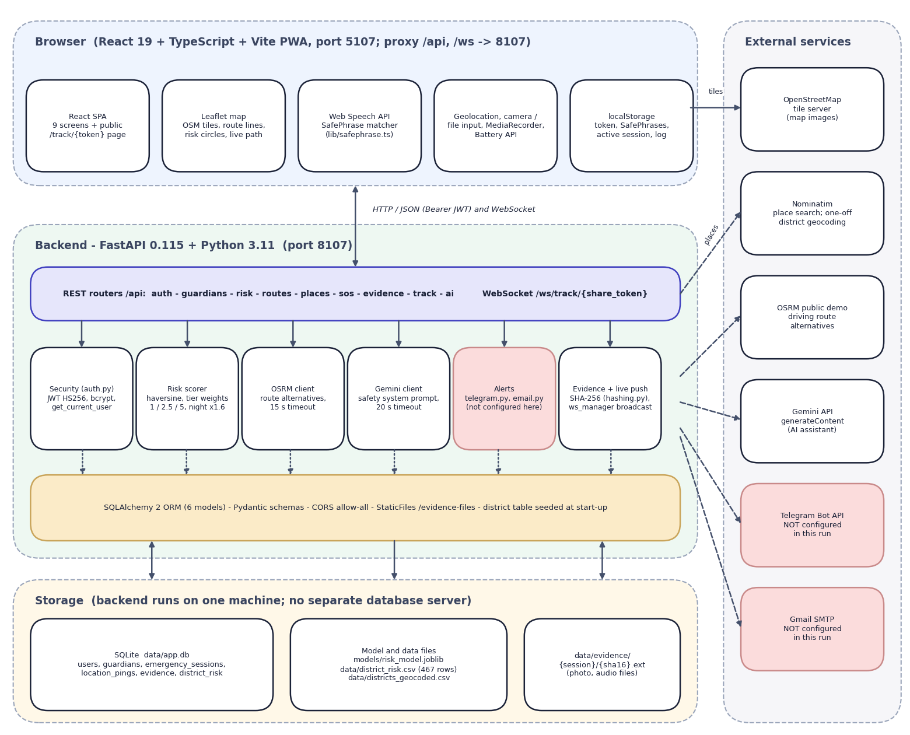
Fig. 1: System architecture of SHEGUARD
The diagram has four layers and a column of outside services. At the top is the browser: a React 19 and TypeScript single-page application built with Vite (port 5107, which proxies /api and /ws to the backend) and installable as a PWA. It contains the nine signed-in and signed-out screens plus the public /track/{token} page, a Leaflet map that draws OpenStreetMap tiles, route lines, risk circles and the live path, the Web Speech API with the SafePhrase matcher (lib/safephrase.ts), the device APIs (geolocation, camera or file input, MediaRecorder, battery), and localStorage, which holds the JWT, the SafePhrase list, the active session and a short activity log.
Below it is the FastAPI application on port 8107. Its ten routers (auth, guardians, risk, routes_plan, places, sos, evidence, track, ai and the WebSocket route ws) call six service blocks: security (bcrypt and HS256 JWT, get_current_user), the risk scorer, the OSRM client, the Gemini client, the alert senders (telegram.py, email.py) and the evidence and live-push helpers (hashing.py, ws_manager.py). SQLAlchemy maps six models to one SQLite file; the district table is seeded from data/district_risk.csv when the application starts. Storage is local: the database, the model and data files (risk_model.joblib and the two district CSV files) and the evidence folder. On the right are the outside services: OpenStreetMap tiles (called by the browser), Nominatim for place search, the OSRM public demo server for route alternatives, the Gemini API for the assistant, and the Telegram Bot API and Gmail SMTP for alerts. The last two are shaded because their credentials were empty in this run, so no alert was ever sent.

2 High-Level Workflow
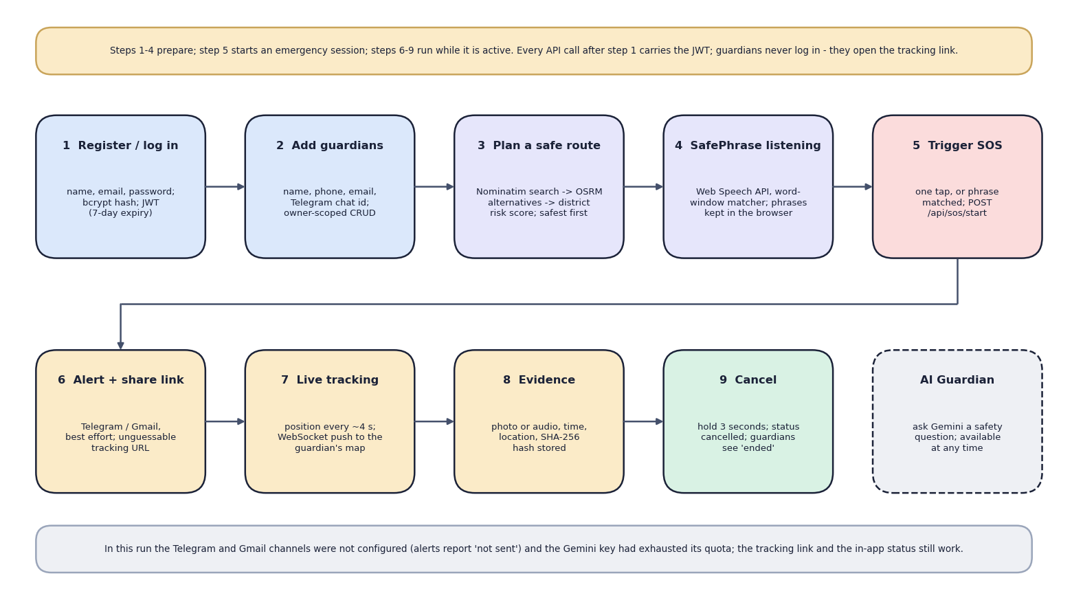
Fig. 2: High-level workflow
The nine steps follow one person from sign-up to the end of an emergency. Steps 1 to 4 prepare: register or log in (a bcrypt-hashed password and a JWT valid for seven days), add guardians, plan a safe route (place search, OSRM alternatives, district risk score, safest first) and keep SafePhrase listening. Step 5 starts an emergency by one tap or a matched phrase and calls POST /api/sos/start. Steps 6 to 9 run while the session is active: the alert and tracking link go to the guardians (Telegram and email, best effort), the position is pushed about every four seconds to the guardian's map, photo or audio evidence is stored with a SHA-256 hash, and holding the cancel button for three seconds ends the session. The dashed tenth box is the AI Guardian, which can be used at any time. The note at the bottom states what did not work in this run: the Telegram and Gmail channels were not configured and the Gemini key had run out of quota.

3 Data-Flow Diagram: Level 0
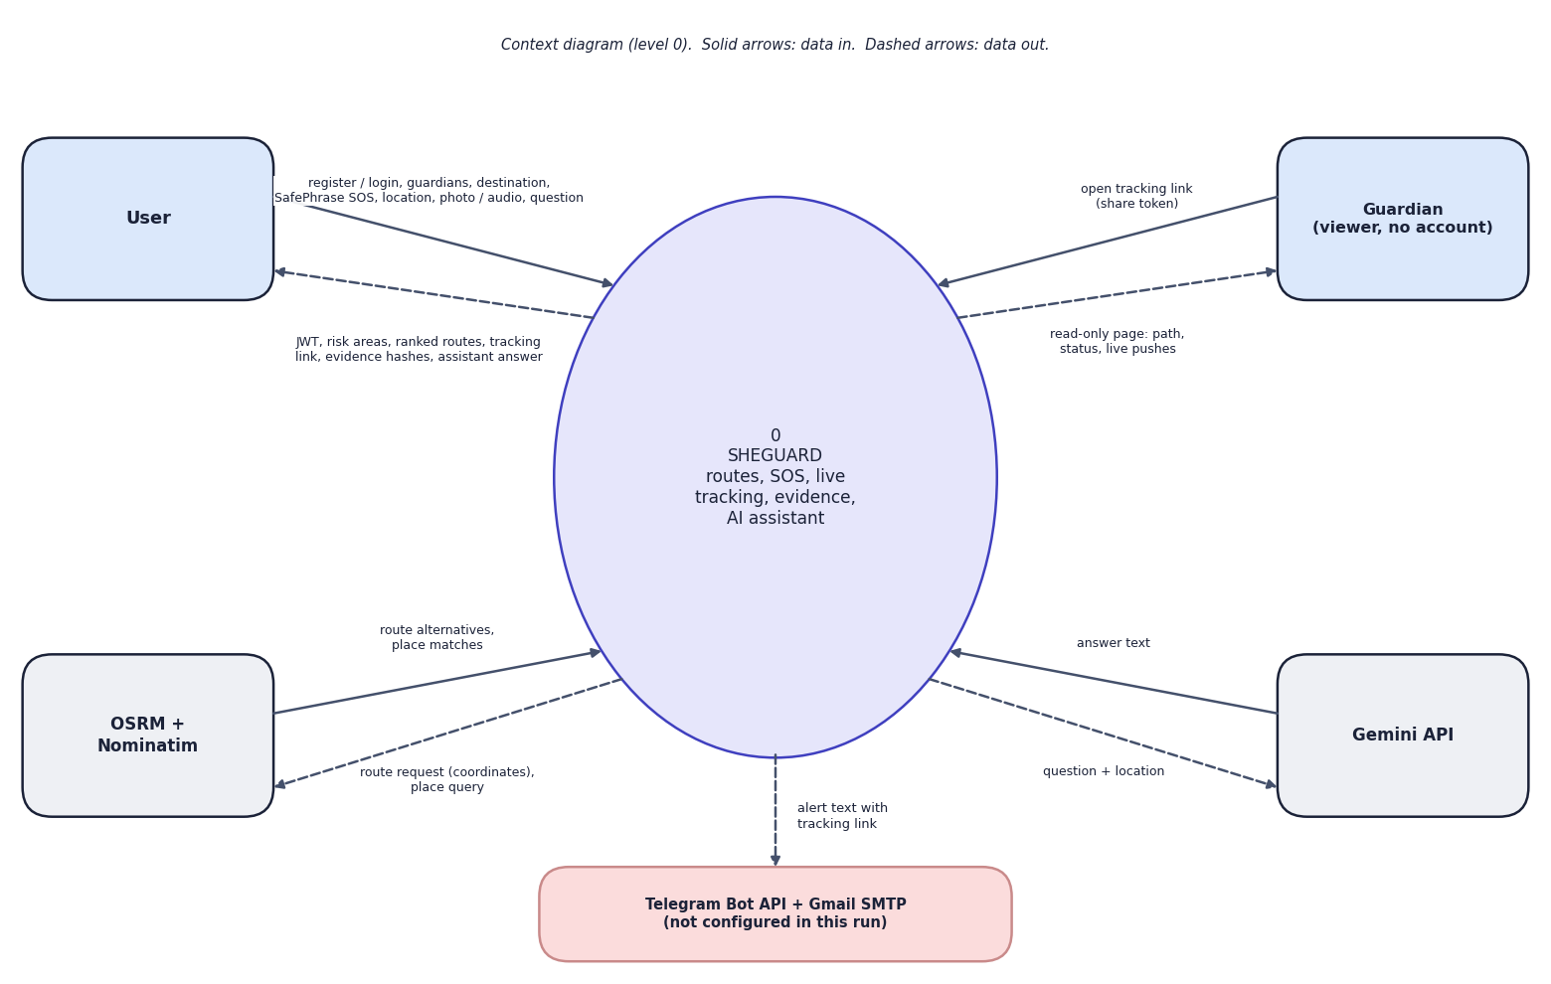
Fig. 3: Data-flow diagram, level 0 (context)
At the highest level SHEGUARD is one process with five external entities. The user sends registration and login details, guardians, a destination, the device location, a SafePhrase or tap that starts an SOS, photo or audio evidence and questions for the assistant; the user receives a token, the risk areas, the ranked routes, the tracking link, the evidence hashes and the assistant's answer. The guardian, who has no account, sends only the share token (by opening the link) and receives a read-only page with the path, the status and live pushes. OSRM and Nominatim receive a route request or a place query and return route alternatives or place matches. The Gemini API receives a question with the user's approximate location and returns text. The process sends an alert text with the tracking link to Telegram and Gmail; both are shaded because they were not configured in this run.

4 Data-Flow Diagram: Level 1
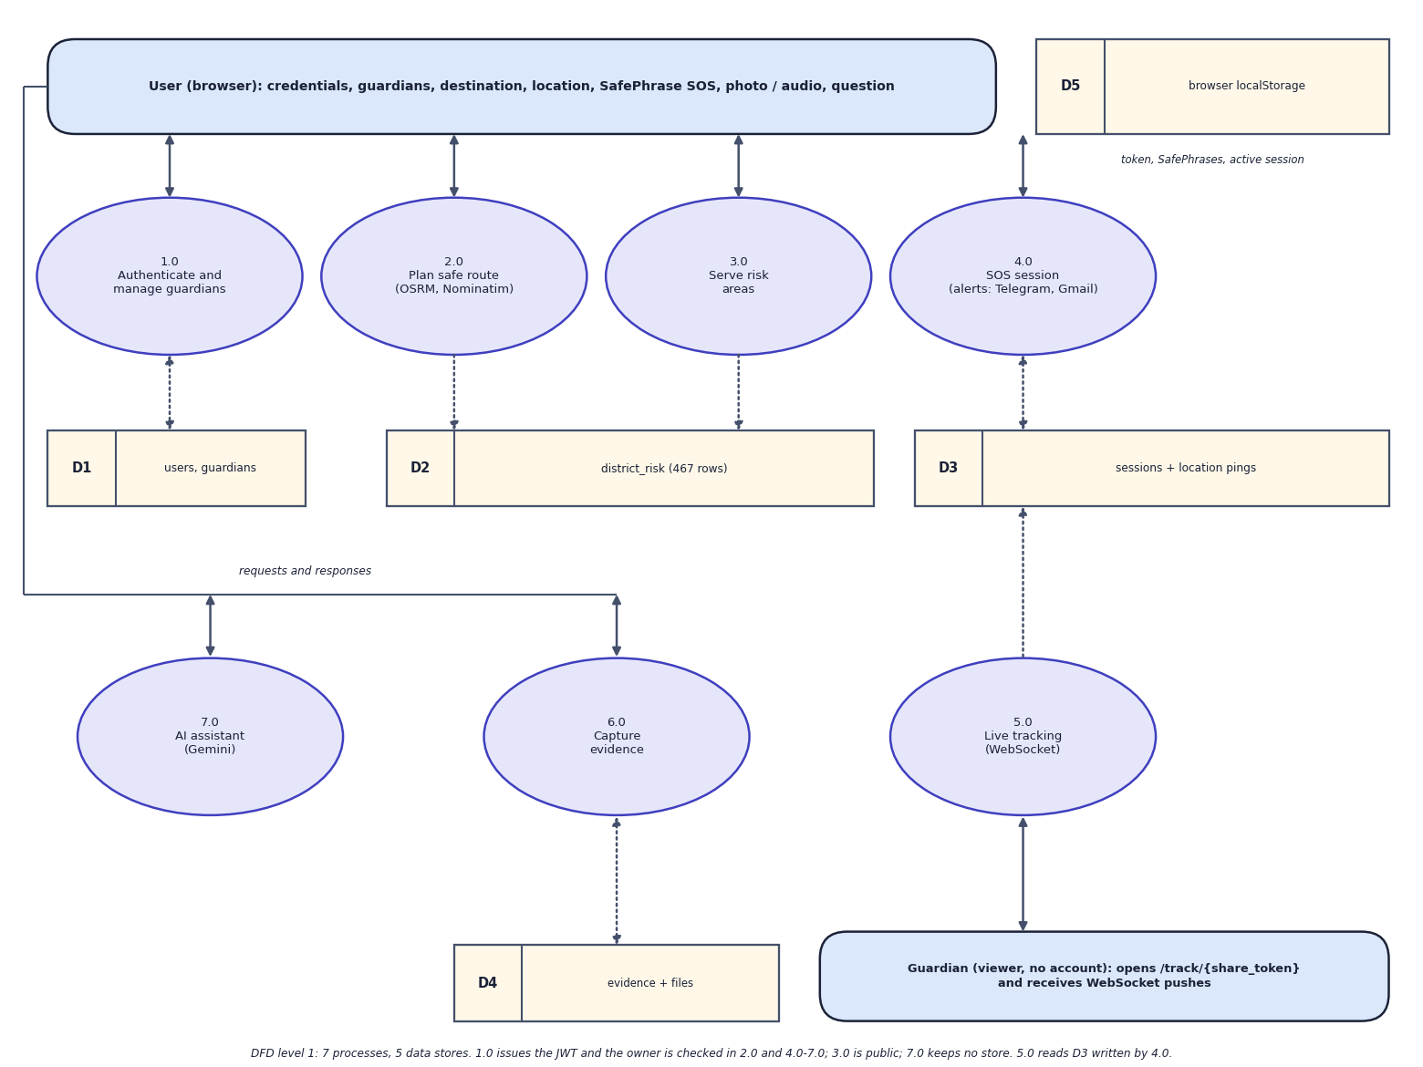
Fig. 4: Data-flow diagram, level 1
Level 1 splits SHEGUARD into seven processes: authenticate and manage guardians (1.0), plan a safe route (2.0), serve risk areas (3.0), SOS session (4.0), live tracking (5.0), capture evidence (6.0) and the AI assistant (7.0). Five data stores are used: D1 holds users and guardians, D2 the 467 district-risk rows, D3 the sessions and location pings, D4 the evidence rows and files, and D5 is the browser's localStorage (token, SafePhrases, active session). Process 1.0 issues the JWT; the owner check is made in 2.0 and 4.0 to 7.0, while 3.0 (GET /api/risk/areas) is public. Process 2.0 only reads D2; 4.0 creates the session and the first ping in D3 and sends the alerts; 5.0 reads D3 and pushes new pings to the guardian over the WebSocket; 6.0 writes D4; 7.0 keeps no store because the assistant has no memory between questions.

5 Data-Flow Diagram: Level 2
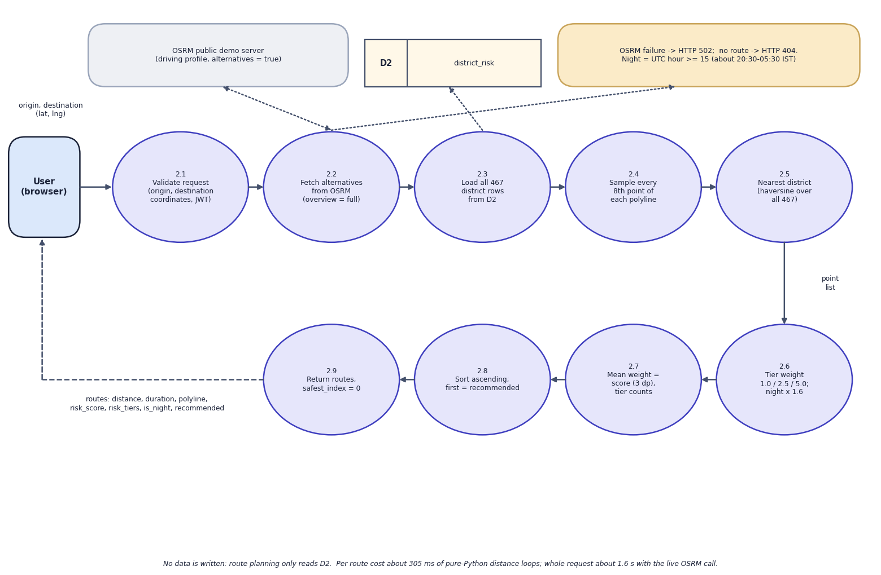
Fig. 5: Data-flow diagram, level 2: Plan safe route (process 2.0)
Process 2.0 is expanded into nine steps that follow plan_route() and score_route(). The request with the origin and destination coordinates is validated and the user is identified from the JWT (2.1). The OSRM public demo server returns driving alternatives with the full geometry (2.2); an OSRM failure gives HTTP 502 and an empty result HTTP 404. All 467 district rows are read from D2 (2.3). Every eighth point of each polyline is sampled (2.4) and mapped to the nearest district by haversine distance over all 467 rows, with no distance limit (2.5). The tier weight (low 1.0, medium 2.5, high 5.0) is applied and multiplied by 1.6 when the server clock is in the night window, UTC hour 15 or later (2.6). The mean weight is the route score, rounded to three decimals, together with the tier counts (2.7); routes are sorted by ascending score and the first is marked recommended (2.8), and the list is returned with safest_index = 0 (2.9). Nothing is written to the database.

6 Use-Case Diagram
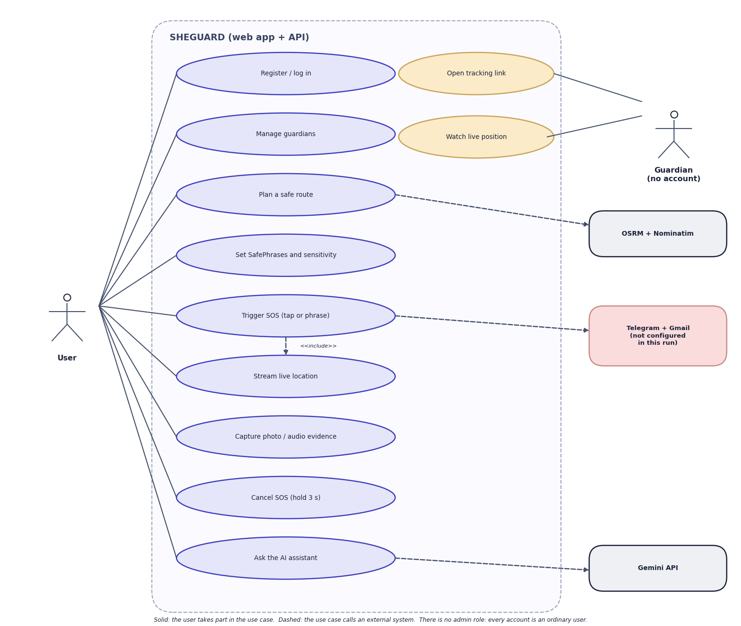
Fig. 6: Use-case diagram
There is one signed-in actor, the user. The user registers or logs in, manages guardians, plans a safe route, sets SafePhrases and their sensitivity, triggers an SOS by tap or phrase, streams the live location, captures photo or audio evidence, cancels the SOS by holding the button for three seconds and asks the AI assistant. Triggering an SOS includes streaming the location. The guardian is the second actor and has no account: the guardian can open the tracking link and watch the live position. The dashed arrows show which use cases call an outside system: route planning calls OSRM and Nominatim, the SOS calls Telegram and Gmail (not configured in this run) and the assistant calls Gemini. There is no administrator role: every account is an ordinary user.

7 Sequence Diagram
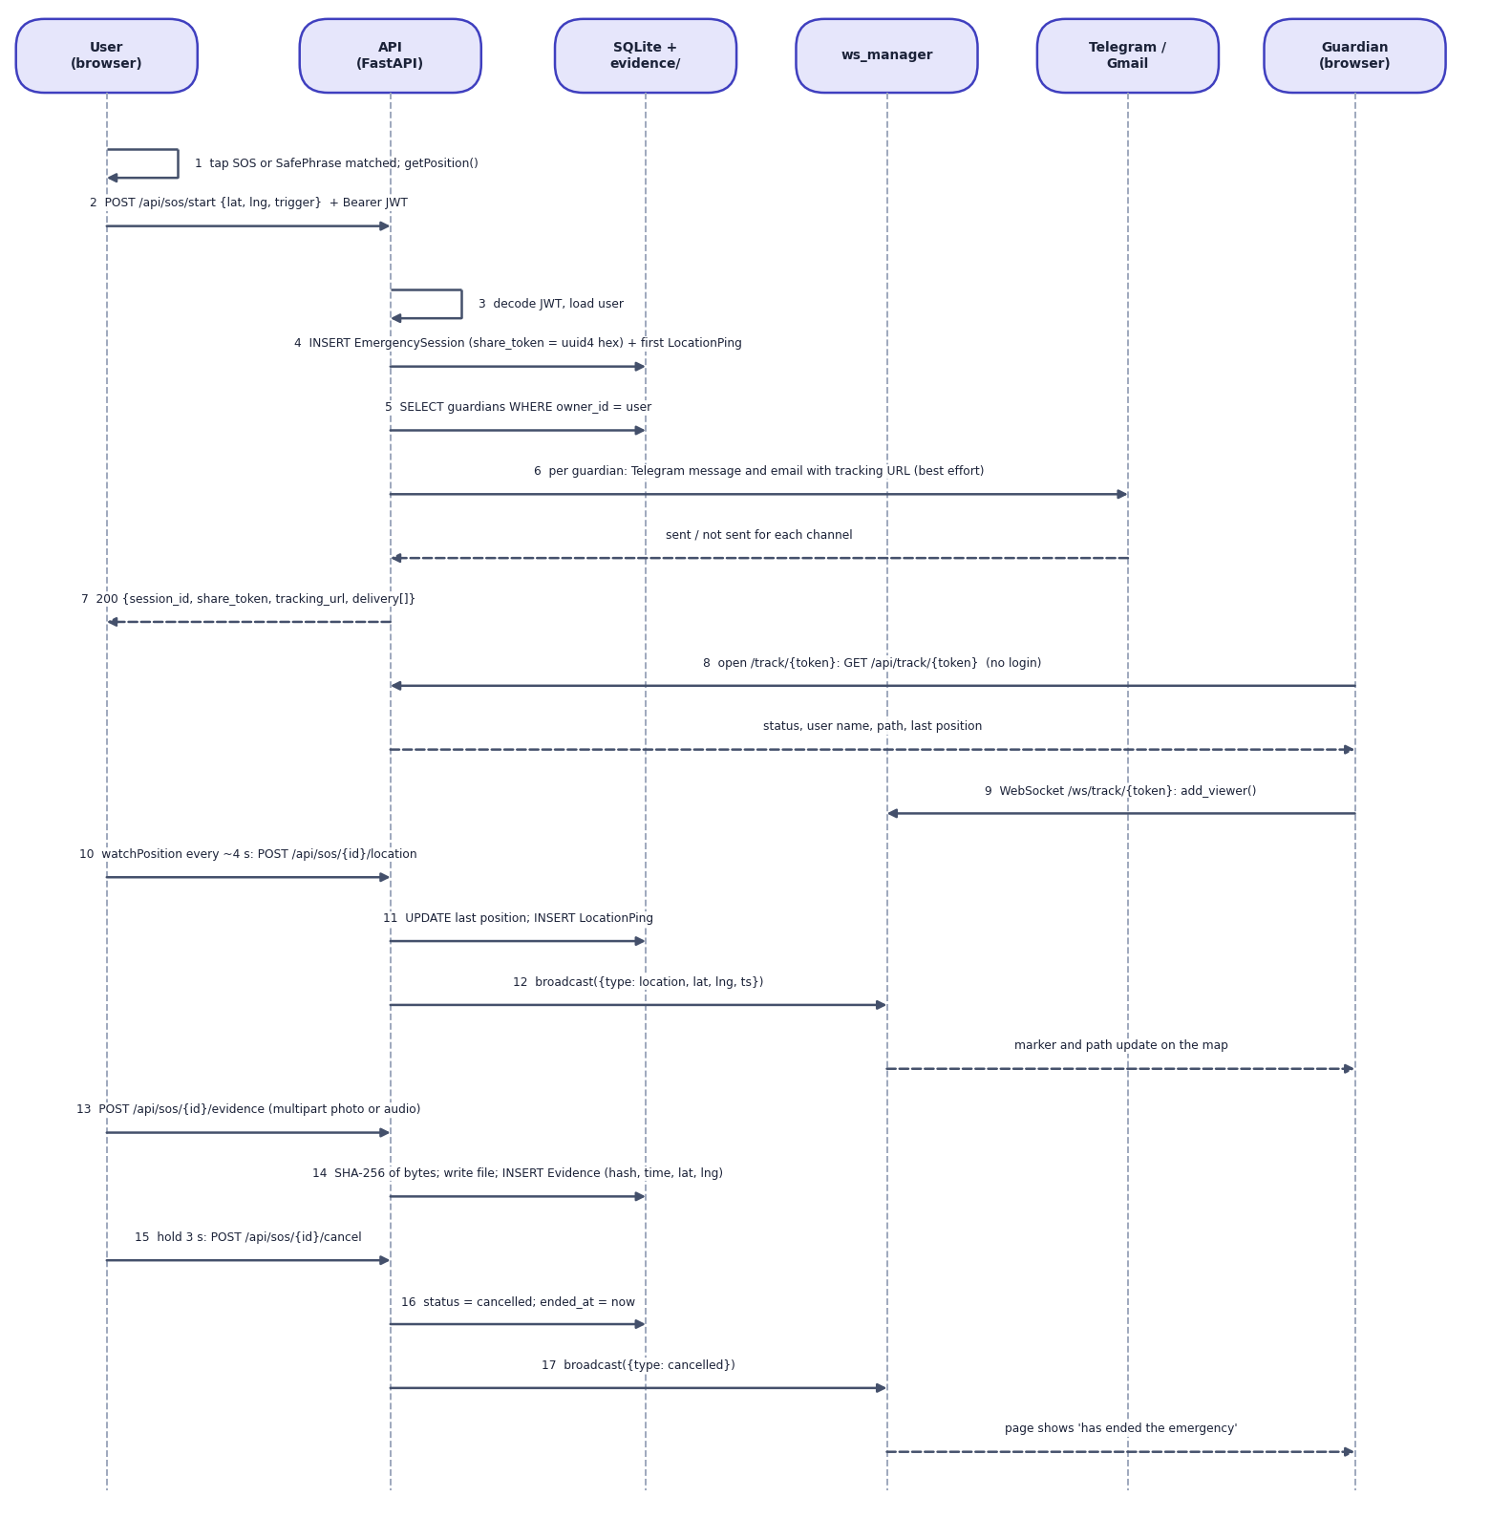
Fig. 7: Sequence diagram: from SOS trigger to cancellation
The sequence shows the main flow in 17 numbered steps across six participants. In the browser, a tap or a matched SafePhrase obtains the position and posts POST /api/sos/start with the bearer token (1, 2). The API decodes the JWT (3), inserts the EmergencySession with a random 32-hex share_token and the first LocationPing (4), reads the owner's guardians (5) and asks the alert senders to send a Telegram message and an email with the tracking URL, each reporting sent or not sent (6); the response carries the session id, the token, the URL and the delivery list (7). A guardian opens the link and the page loads the path with GET /api/track/{token} without logging in (8), then opens the WebSocket, which registers the viewer in the connection manager (9). About every four seconds the browser posts a new position (10); the API updates the session and stores a ping (11) and the manager broadcasts it (12), so the marker and path move on the guardian's map. Evidence is uploaded as multipart data, hashed with SHA-256, written to disk and recorded (13, 14). Holding the cancel button for three seconds posts the cancellation (15); the status becomes cancelled (16) and a cancelled message is broadcast (17), after which the guardian's page says that the emergency has ended.

8 Entity-Relationship Diagram
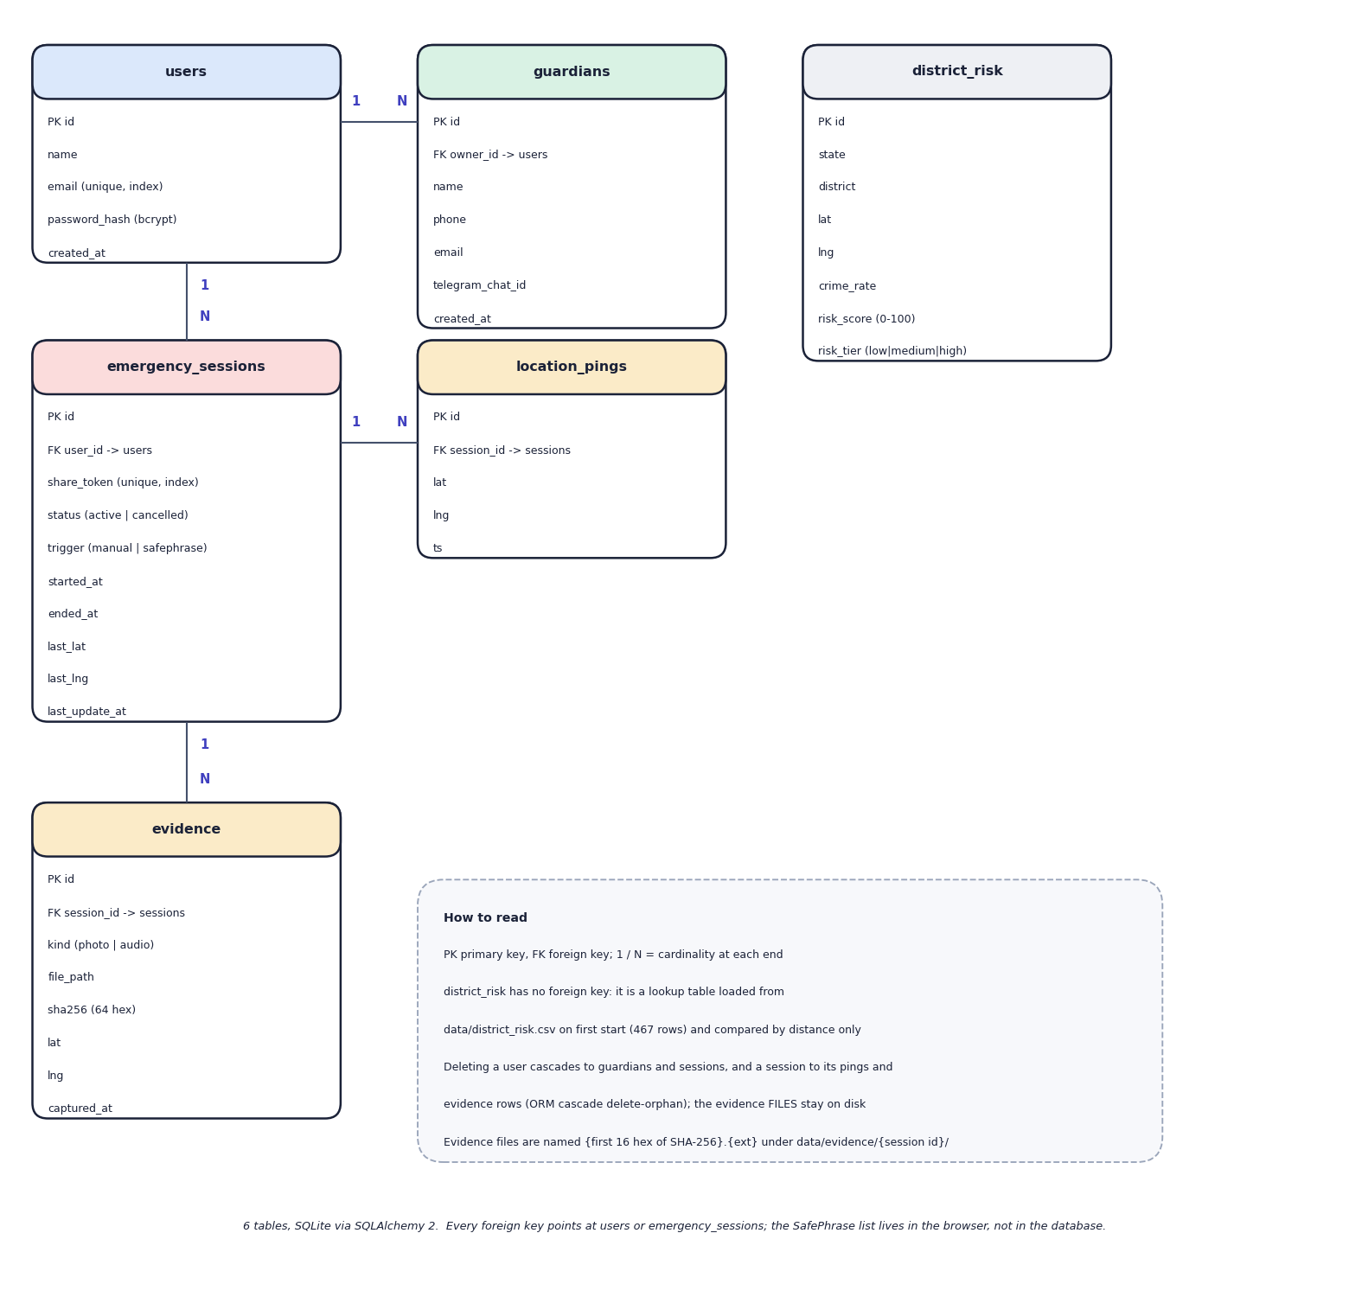
Fig. 8: Entity-relationship diagram (6 tables)
Six tables are created by SQLAlchemy in SQLite. A user owns many guardians and many emergency sessions; a session has many location pings and many evidence rows. The district_risk table is a lookup table with no foreign key: it holds the 467 geocoded districts with their crime rate, 0-100 risk score and tier, and is read by distance only. ORM cascades delete a user's guardians and sessions and a session's pings and evidence rows, but the evidence files stay on disk. The SafePhrase list is not in the database: it lives in the browser. The evidence.file_path column holds the path relative to data/, and the file name is the first 16 hexadecimal characters of the SHA-256 followed by the extension.

9 UML Class Diagram
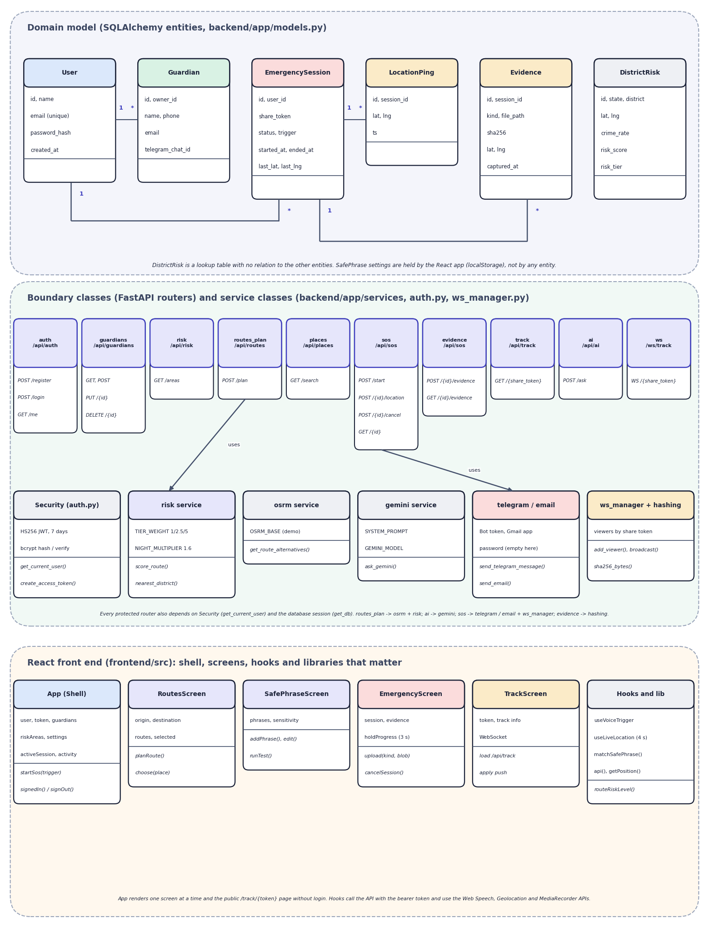
Fig. 9: UML class diagram
The upper part shows the six SQLAlchemy entities with their main attributes: User has many Guardian and many EmergencySession; a session has many LocationPing and many Evidence; DistrictRisk stands alone. The middle part shows the boundary classes, the ten routers with their routes, and the service classes behind them: security (get_current_user, create_access_token), the risk service with its tier weights and the night multiplier (score_route, nearest_district), the OSRM client, the Gemini client with its system prompt, the Telegram and email senders, and the connection manager with the hashing helper. Arrows show that routes_plan uses the OSRM client and the risk service and that sos uses the senders and the manager. The lower part shows the React side: the App shell that holds the user, the token, the guardians, the SafePhrase settings and the active session; the route, SafePhrase, emergency and tracking screens; and the hooks and libraries (useVoiceTrigger, useLiveLocation, matchSafePhrase, api, getPosition).

10 Flowchart of the Core Algorithm
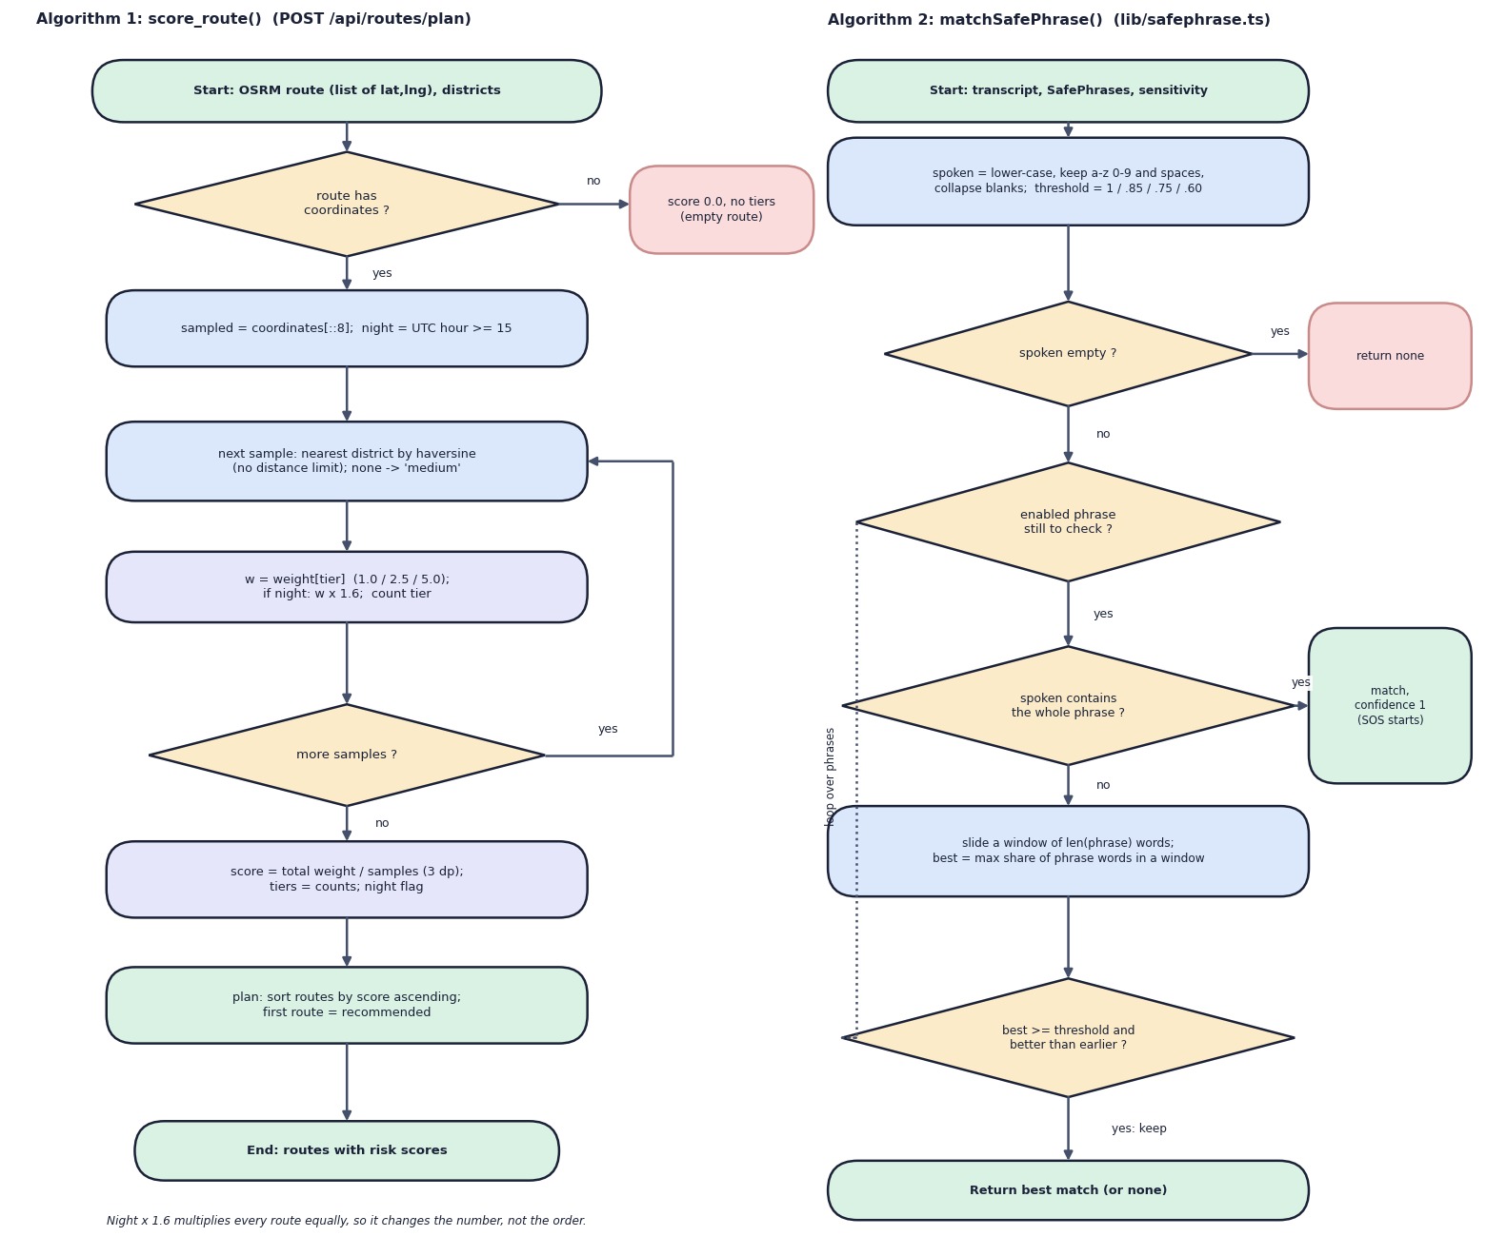
Fig. 10: Flowcharts of the two core algorithms: score_route() and matchSafePhrase()
The left flowchart is the route-scoring algorithm. An empty route scores 0.0 with no tiers. Otherwise every eighth coordinate is sampled; for each sample the nearest district is found by haversine distance (a missing district counts as medium), the tier weight is taken, multiplied by 1.6 at night, and the tier is counted. When no samples remain, the score is the total weight divided by the number of samples, rounded to three decimals. The planner then sorts the routes by ascending score and marks the first as recommended. The note under the chart states a consequence of the design: because the night factor multiplies every route by the same number, it changes the displayed score but never the order.
The right flowchart is the SafePhrase matcher that runs in the browser on every recognition result. The transcript is lower-cased, reduced to letters, digits and single spaces, and an empty result returns no match. For each enabled phrase, a whole-phrase substring match returns a match with confidence 1 and the SOS starts. Otherwise a window as long as the phrase is slid across the transcript, the best share of phrase words found in a window is kept, and the phrase counts only if that share reaches the sensitivity threshold (Low 1.0, Medium 0.85, High 0.75, Ultra 0.60) and beats any earlier phrase. The best match, or none, is returned.

